 | FACULTY OF COMPUTING  UNIVERSITI TEKNOLOGI MALAYSIA

SECJ3032 PSM 1/FYP 1
SUPPLEMENTARY DOCUMENT FOR PROJECT PROPOSAL

SECTION A: STUDENT INFORMATION

Name: | Ahmed Hani Ahmed Ghaleb
Year/Course: | 2122/SECJH
Matric No.: | A21EC9120 | Mobile No.: | 01112344710
Email: | ahmedahmed@graduate.utm.my
Date: | 3 April, 2025 | Signature: | 

SECTION B: SUPERVISOR ACKNOWLEDGEMENT
Supervisor Name: | DR. MUHAMMAD LUQMAN BIN MOHD SHAFIE
Email: | muhammadluqman.ms@utm.my | Mobile No. |  | +60 13-896 1412
Consent: | I ACKNOWLEDGE that I have reviewed Sections C and D and have ensured that I fulfill the TOR in Section E.
Signature & Official Stamp: |  | Date: | 3 April, 2025

SECTION C: NABC CANVAS

The purpose of this section B is to provide a concise overview of the project concepts (as outlined in the NABC segment) and important aspects of stakeholder and respondents/data involved.
Need | The hall owner spends a disproportionate amount of time addressing repetitive phone inquiries regarding basic information (availability, pricing, features). Owner overwhelmed by basic info calls. Customers (esp. culturally relevant female stakeholders) need easy online access to visuals, availability, pricing. There is a need to streamline information dissemination and improve the customer experience.
Approach | Develop a user-friendly website featuring an interactive availability calendar, customizable pricing information, a comprehensive FAQ section, and a visual gallery of the hall. The website will be accessible 24/7 and managed through a secure administrator panel. This cloud-based approach will provide a centralized source of information, reducing the need for individual phone inquiries and enhancing the hall's marketing presence. Furthermore, the system will incorporate essential functionalities such as basic reporting capabilities for the owner, a mechanism for visitors to submit feedback, automated notifications via locally preferred channels like SMS or WhatsApp, and a simple, optional feature allowing users to upload proof of payment (e.g., transfer screenshot) to confirm bookings, aligning with common local practices.
Benefits | * Enhanced Marketing: Showcases the hall's features and attracts new clients through a professional online presence. Specifically, in the Arab culture, providing a detailed website with high-quality visuals allows women, who may have limited opportunities to physically visit the hall, to thoroughly evaluate the venue from the comfort of their homes. This empowers them to confidently recommend the hall to their families and future husbands, who ultimately make the reservation decision.  * Reduced Time for the Owner: Significantly reduces time spent answering repetitive phone inquiries, allowing the owner to focus on other business priorities.  Improved Operational Oversight: Basic reports offer the owner valuable insights into inquiry trends, booking patterns, and user feedback, aiding decision-making.  Streamlined Booking Confirmation: The optional payment proof upload provides a simple mechanism to confirm bookings without complex integrations, fitting the local context.  Enhanced Communication & Service Improvement: Notifications keep clients informed (e.g., inquiry received, booking confirmed), while the feedback system provides a direct channel for user suggestions and identifying areas for improvement.
Competition | Current System: Manual phone calls (inefficient).  - rsvpify.com – Too complex. Requires monthly subscription.  - Whova.com, eventpro.net, cvent.com – All of them show Static info, require contact for availability/pricing. (These websites seem to have highly customizable software for business owners, however they require prior communication & no clear quotation)  - ikrizainvite.my/ : Event management system designed for guests, not business owners.  - Unique Value: Al-Muneer Online Portal is bespoke:  - Tailored, easily managed dynamic pricing & availability for this specific hall.  - Theme curated for Al-Muneer's audience and cultural context.
Potential Stakeholders (System Development-based ONLY) | Ahmed Almunajid – Reservation Hall business
Potential Data or Respondents (Research-based ONLY)
References | https://rsvpify.com/  https://www.cvent.com/en/event-management-software  https://whova.com/  https://rsvpify.com/  https://www.capterra.com/event-management-software/  ikrizainvite.my/  https://ekaddigital.com/theweddingcard/AG12082
Notes:
- Need (N): Specific need or problem that the proposed system, addresses within the given domain. Provides strong and relevant evidence to support the need.
- Approach (A): Clearly laid-out plan for how the proposed system will work (eg: mobile app, cross-platforms, cloud-based, or uses AI/smart technology etc.), explaining how its main features operate in detail.
- Benefit (B): Significant benefits of the proposed system offers to the specific users.
- Competitor (C): Other similar products or solutions already available, emphasizing how the proposed system is different.
- Potential Stakeholder (System Development-based ONLY): Individual/person, group of people, or an organisation that can affect or be affected by the project //Evidence of stakeholder agreement/willingness
- Potential Data/Respondent (Research-based ONLY): Evidence of data sources or respondents are relevant and aligned with the research objectives.
- References to other documents, books or related online resources must be properly cited in the tex

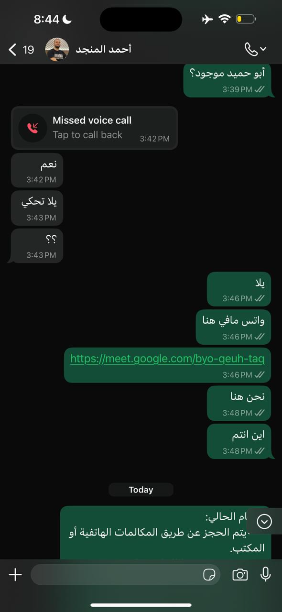
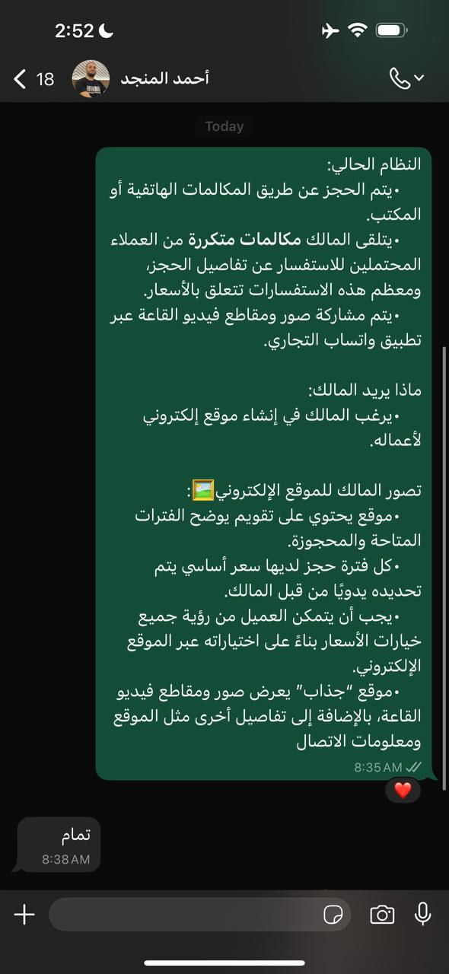
screenshot 1 Screenshot 2
Screenshot 1: shows a meeting held on Google Meet Thursay between Ahmed Ghaleb and the stakeholder Ahmed Almunjid to discuss and elicite requirements
Screenshot 2: Translation:
Current System:
- Reservations are made via phone calls or the office.
- The owner receives frequent calls from potential clients inquiring about booking details, and most of these inquiries relate to prices.
- Photos and videos of the hall are shared via the WhatsApp Business application.
What the owner wants:
- The owner wants to create a website for his business.
The owner's vision for the website:
- A website containing a calendar showing available and booked slots.
- Each booking slot has a base price manually set by the owner.
- The customer should be able to see all pricing options based on their selections via the website.
- A "fancy" website that displays photos and videos of the hall, in addition to other details such as location and contact information.

SECTION D: PROPOSED USE CASE DIAGRAM
The purpose of this section C is to briefly illustrate the features (use cases) and potential users i.e., end-user and Admins (actors) of the proposed system (Only for System Development PSM/FYP category).

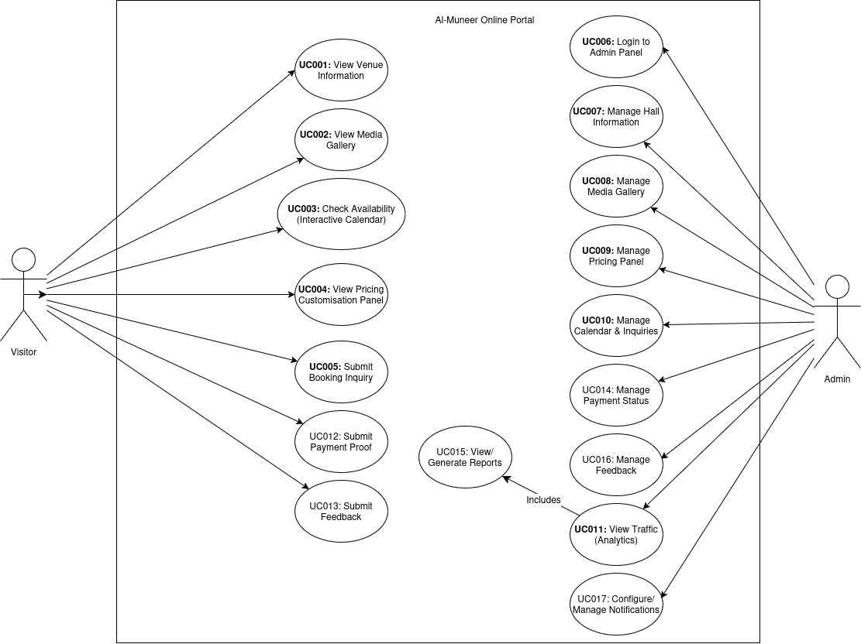

SECTION E: SUPERVISOR'S TERMS OF REFERENCE (TOR)

The supervisor needs to:
- Have a significant knowledge of software engineering principles in applying software development life cycle.

- Have experience in relevant programming languages and tools related to the project.

- Understand software project management methodologies (e.g. Plan-driven, Agile, Scrum, DevOps, etc.).

- Provide constructive feedback on project progress, documentation, and implementation.

- Ensure proper documentation and adherence to software quality standards , including maintainability, scalability, and security best practices.

- Encourage ethical software development practices, including responsible coding, intellectual property considerations, and professional conduct.

- Be aware that a functional prototype is required for research-based projects and guide students in meeting this expectation.

